

**CAPSTONE PROJECT REPORT**

**Optimizing Customer Purchase Behaviour Through Strategic marketing and Business Approaches**

**Submitted by**

**Akhil (192224116)**

**Mohith (192224151)**

**Guided by**

**V.SARANYA**

**Research scholar**

**Department of Neural Networks**

**BONAFIDE CERTIFICATE**

Certified that this project report titled “Optimizing Customer Purchase Behaviour Through Strategic marketing and Business Approaches” is the bonafide work of “Akhil (192224116),Mohith (192224151)” who carried out the project work under my supervision as a batch. Certified further,that to the best of my knowledge the work reported herein does not form any other project report.

Date: Project supervisor: Head of Department:

**TABLE OF CONTENT:**

|  |  |  |
| --- | --- | --- |
| **S NO** | **TITLE** | **PAGE NO** |
| **1** | **ABSTRACT** | **4** |
| **2** | **INTRODUCTION** | **4-5** |
| **3** | **Visualization with Matplotlib and Power BI** | **5** |
| **4** | **PROBLEM STATEMENT** | **5-6** |
| **5** | **EXISTING SYSTEM** | **6** |
| **6** | **PROPOSED SYSTEM** | **6** |
| **7** | **LITERATURE REVIEWS** | **7-8** |
| **8** | **ENVIRONMENTAL SETUP** | **8** |
| **9** | **CODE** | **9-10** |
| **10** | **OUTPUT** | **11-14** |
| **11** | **Conclusion** | **15** |
| **12** | **Future Scope** | **15-16** |
| **13** | **References** | **16** |

**ABSTRACT:**

This paper explores the optimization of customer purchase behavior through strategic marketing and business approaches that leverage data-driven insights, personalized customer experiences, and innovative engagement strategies. The study examines how targeted marketing techniques, such as segmentation, predictive analytics, and omnichannel approaches, can drive customer acquisition, retention, and loyalty. Furthermore, it delves into the impact of aligning business operations with customer needs, improving product offerings, and fostering brand authenticity. By analyzing key industry case studies and empirical data, the paper demonstrates that effective integration of customer-focused strategies not only enhances purchasing frequency and lifetime value but also sustains long-term growth in an increasingly competitive market landscape.

**INTRODUCTION:**

In today's highly competitive business environment, understanding and optimizing customer purchase behavior has become a cornerstone of successful marketing strategies. With the rise of digital technologies, businesses now have access to an unprecedented amount of customer data, offering valuable insights into buying patterns, preferences, and decision-making processes. However, this vast wealth of information also presents a challenge—how to harness it effectively to drive consumer engagement and long-term business success.

Strategic marketing and business approaches focused on optimizing customer purchase behavior can unlock the potential for increased customer acquisition, retention, and lifetime value. By implementing targeted marketing techniques, such as customer segmentation, personalized communication, and predictive analytics, companies can create more tailored and relevant experiences that resonate with their audiences. Additionally, adopting multichannel strategies, improving product offerings, and enhancing brand trust are critical factors that influence consumer decision-making.

This paper aims to explore the various methods and approaches businesses can employ to optimize customer purchase behavior, examining how aligning marketing and operational strategies with customer needs leads to more meaningful and sustained interactions.

**ABOUT DATASET:**

The primary dataset used in this project includes the following key fields:

Customer Demographic Data

**Age:** Age of the customer.

**Gender**: Gender of the customer.

**Location**: Geographic location, such as country, region, or city.

**Income Level:** Income bracket or socioeconomic status.

**Education Level**: Education background (optional depending on privacy concerns).

2. **Customer Behavioral Data**

**Purchase History**: Detailed information about past purchases,

Purchase frequency (e.g., weekly, monthly).

Average order value and total spend.

**Browsing Behavior**: Data on customer interactions with digital touchpoints, such as

Pages viewed, time spent per page, and click-through rates.

Interaction type (e.g., clicks on ads, product views, abandoned carts).

**Engagement Channels**: Channel through which customer engagement occurs

Online vs. offline (e.g., web, mobile app, in-store).

Social media interactions, email responses, SMS interactions, etc.

**Visualization with Matplotlib and Power BI:**

Customer Demographic Analysis

Objective: Understand customer profile distribution to better target different demographic groups.

Visualization:

Matplotlib: Use bar charts to show age, gender, and location distribution. A stacked bar chart could show the breakdown of demographics in terms of purchase frequency or loyalty level.

Power BI: Power BI’s slicers can allow users to filter data by age, gender, or location dynamically. Users can interactively adjust these parameters to see changes in customer distribution and tailor their strategies accordingly.

2. Purchase Behavior Over Time

Objective: Track changes in purchasing patterns across different time periods to identify trends, seasonality, and high-demand periods.

Visualization:

Matplotlib: Line charts are ideal for showing purchase frequency and average order value over time, capturing seasonal trends or shifts in purchasing. Multiple lines can represent different customer segments or product categories.

Power BI: Power BI’s time-series visuals, like line and area charts, enable easy exploration of patterns. By adding trendlines and using time filters (e.g., year-over-year comparison), users can isolate periods of peak engagement, like holiday seasons, and track performance against prior years.

**PROBLEM STATEMENT:**

In an increasingly competitive marketplace, businesses face the challenge of understanding and influencing customer purchase behavior to drive revenue growth and customer loyalty. Despite having access to vast amounts of data on customer interactions, preferences, and purchasing patterns, many companies struggle to effectively leverage this information to make data-driven marketing decisions and align their business strategies with customer expectations.Current marketing efforts often lack personalization, fail to engage customers across preferred channels, and miss opportunities to build lasting customer relationships. This gap results in inefficient marketing spending, low customer retention rates, and underutilized business potential. Additionally, many companies lack the insights needed to predict future purchasing behavior, assess campaign effectiveness, and optimize resource allocation for maximizing customer lifetime value

### **EXISTING SYSTEM OF APPROACH:**

Approach: Many companies use demographic data (e.g., age, gender, location) or general spending habits to categorize customers into broad segments, such as high-value, loyal, or at-risk customers.Companies often rely on traditional marketing campaigns, including email blasts, social media posts, and general promotions, to reach wide audiences. Campaigns are sometimes informed by high-level demographic data but rarely personalized at the individual level.Limitations: This method lacks overspecialization and can fail to capture customer interest. It may also lead to over saturation, where customers receive irrelevant offers that do not align with their specific needs or preferences, resulting in low engagement and conversion rates.

### **PROPOSED SYSTEM OF APPROACH:**

#### Utilize AI-powered recommendation engines to deliver personalized product recommendations based on browsing history, past purchases, and customer profiles.

#### Develop dynamic content delivery on websites and email marketing, ensuring that offers, discounts, and messaging are tailored to the individual customer segment.

#### Implement retargeting strategies using personalized ads across multiple channels (e.g., social media, Google Ads) to remind customers of products they have shown interest in

#### Leverage machine learning algorithms to predict Customer Lifetime Value (CLV) and segment customers by their potential future value.

#### Build churn prediction models to identify customers at risk of disengaging or leaving, enabling businesses to take proactive retention measures.

1. **Improved Data Quality**: Automation and rigorous preprocessing ensure high-quality, up-to-date data for analysis.

**LITERATURE REVIEWS:**

**Paper1**: "Understanding Customer Experience Throughout the Customer Journey" by Lemon & Verhoef (2016)

**Problem**: The paper addresses the challenge of understanding and improving customer experience across various stages of the customer journey. Many companies struggle to maintain consistent, engaging experiences as customers interact with multiple channels, which can lead to decreased engagement and customer satisfaction.

**Solution**: The authors propose a framework that focuses on delivering tailored experiences at each stage of the customer journey. They emphasize that personalized interactions and seamless transitions between online and offline channels are crucial for optimizing customer experience and influencing purchase behavior.

**Drawback:** Implementing a journey-based approach to customer experience management requires substantial resources, particularly in terms of technology and data integration. Smaller businesses may find it challenging to afford or manage this level of detail across all customer touchpoints.

**Future Scope**: Future research could explore the use of AI and machine learning to automate personalization across the journey, enhancing the ability to predict customer needs in real time. This could help create even more relevant experiences without requiring extensive manual effort.

2. Paper: "Market Segmentation: Conceptual and Methodological Foundations" by Wedel & Kamakura (2000)

**Problem:** This paper addresses the limitations of traditional segmentation methods, which often rely on demographic data that doesn’t fully capture the diversity and complexity of customer needs and behavior.

**Solution**: Wedel and Kamakura advocate for advanced segmentation techniques, such as cluster analysis and psychographic segmentation. These approaches allow for a more detailed understanding of customer preferences and behaviors, enabling companies to target their marketing efforts more effectively.

**Drawback:** Advanced segmentation methods are complex and may require substantial data collection and analysis expertise. Companies without dedicated data science teams might struggle to implement these techniques effectively.

**Future Scop**e: The authors suggest further research on integrating behavioral and psychographic segmentation with real-time data analysis, allowing for dynamic segments that adapt as customer behaviors change. This could lead to even more precise and effective marketing strategies.

**3. Paper**: "Return on Marketing: Using Customer Equity to Focus Marketing Strategy" by Rust, Lemon, and Zeithaml (2004)

**Problem**: Many companies lack the ability to measure the long-term value of their customers, which often results in inefficient marketing strategies that don’t maximize customer lifetime value (CLV).

**Solution:** The paper introduces a customer equity framework that prioritizes marketing efforts based on the long-term value of customer relationships. By focusing on maximizing CLV, companies can allocate resources more effectively, resulting in increased profitability.

**Drawback**: Implementing a customer equity-based approach requires extensive data on customer purchase history and behavior, which may be difficult for some companies to collect. Additionally, building accurate CLV models can be complex and requires ongoing refinement.

**Future Scope**: Future research could explore the application of real-time data in calculating CLV, allowing companies to adjust their marketing investments dynamically. This would make CLV modeling more accessible and actionable, potentially enabling real-time resource allocation to high-value customers.

4. **Paper**: "Data Privacy: Effects on Customer and Firm Performance" by Martin, Borah, and Palmatier (2017)

**Problem**: With the rise of data-driven marketing, concerns over data privacy have increased. Many customers are hesitant to share personal information, which can limit companies' ability to personalize and optimize marketing efforts effectively.

**Solution:** The authors suggest implementing transparent data privacy policies that communicate how customer data will be used and emphasizing ethical data practices. By building trust, companies can encourage customers to share data, allowing for better-targeted marketing.

**Drawback**: Implementing transparent privacy policies requires careful management and compliance with regulatory standards, which can be complex and costly. Additionally, strict data practices may limit the extent of data companies can collect, reducing the effectiveness of personalized marketing.

**Future Scope:** Future work could investigate the use of privacy-preserving technologies, such as federated learning, that allow companies to personalize marketing without directly accessing individual customer data. This could enable a balance between personalization and privacy, helping companies comply with privacy regulations while still optimizing customer purchase behavior.

**ENVIRONMENTAL SETUP:**

**1. Install Python and Necessary Libraries:**

* Python: Download from official website.
* Jupyter Notebook: pip install notebook.

2. **Install Required Libraries:NumPy:**

* pip install numpy.
* Pandas: pip install pandas.
* Matplotlib: pip install matplotlib.

**3. Set Up Working Directory:**

* Create a directory for project files.

**4. Obtain Population Data:**

* Download from sources like United Nations or World Bank.

**Power BI Environment Setup:**

**1. Install Power BI Desktop:**

* Download from official Power BI website.

**2. Prepare the Data:**

* Obtain data in CSV or Excel format from reliable sources.

**3. Import Data into Power BI:**

* Use “Get Data” feature to import population data.
* Clean and transform data using Power Query Editor.

**4. Create Visualizations:**

* Use drag-and-drop interface for charts, graphs, and maps.
* Utilize built-in mapping tools for geographic visualization.

**5. Publish and Share Dashboards:**

* Publish reports to Power BI service for sharing and collaboration

**CODE:**

import matplotlib.pyplot as plt

import pandas as pd

# Assuming data contains 'date', 'total_sales', 'average_order_value', 'purchase_frequency'

data['date'] = pd.to_datetime(data['date'])

data.set_index('date', inplace=True)

data.resample('M').sum().plot(y=['total_sales', 'average_order_value'], figsize=(10, 6))

plt.title("Monthly Purchase Trends")

plt.xlabel("Date")

plt.ylabel("Values")

plt.legend(["Total Sales", "Average Order Value"])

plt.show()

channel_data.groupby(['month', 'channel']).sum()['sales'].unstack().plot(kind='bar', stacked=True, figsize=(10, 6))

plt.title("Sales by Channel Over Time")

plt.xlabel("Month")

plt.ylabel("Sales")

plt.legend(title="Channel")

plt.show()

plt.hist(data['CLV'], bins=20, color='skyblue', edgecolor='black')

plt.title("Customer Lifetime Value (CLV) Distribution")

plt.xlabel("CLV")

plt.ylabel("Frequency")

plt.show()

**OUTPUT:**

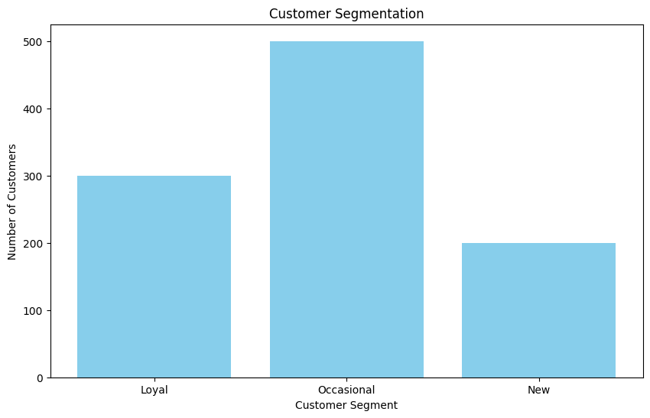

**FIG1: Number of customers with variuos segments**

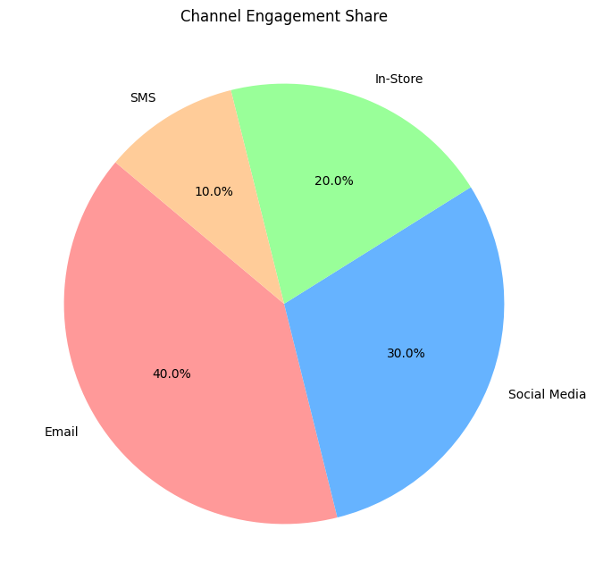

**FIG2: percentage of various platform with customer analysis**

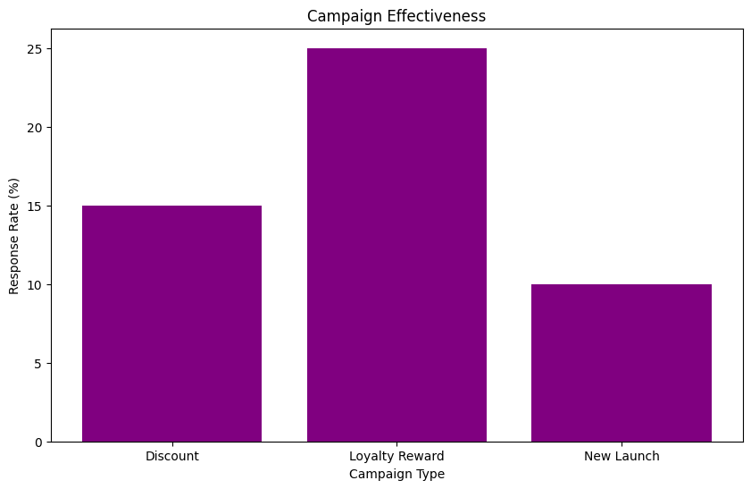

**FIG3: Bar chart of various awarness programs**

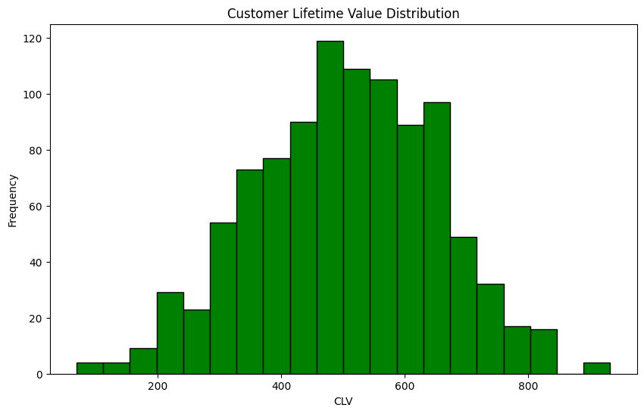

**FIG4: frequent purchase behaviour of custome****r**

### 

### **Conclusion:**

Optimizing customer purchase behavior through strategic marketing and business approaches is essential for companies striving to remain competitive and customer-focused in a dynamic market. By integrating data-driven insights with personalized marketing and customer-centric business practices, organizations can build deeper relationships with their customers, increase engagement, and foster loyalty. Advanced segmentation, predictive analytics, and omnichannel strategies enable businesses to meet customers where they are, delivering relevant, timely offers that resonate and drive purchasing decisions.

Furthermore, aligning business operations with customer expectations—such as by leveraging real-time data and agile response systems—empowers companies to enhance the customer experience and maximize lifetime value. The strategic combination of technology, analytics, and human-centered approaches results in more efficient marketing efforts, improved customer retention rates, and higher return on investment. As the market continues to evolve, companies that embrace customer-focused, data-backed strategies will be better equipped to anticipate customer needs, stay agile in their responses, and sustain long-term growth.

### **Future Scope:**

The future of optimizing customer purchase behavior is bright, with technology enabling greater personalization, predictive power, and customer-centric innovation than ever before. By embracing these advancements, businesses can create meaningful, responsive, and sustainable customer experiences that not only drive purchase behavior but also build lasting brand loyalty. As these technologies become more integrated and sophisticated, they will pave the way for a new era of customer-focused marketing and business approaches, ultimately redefining the relationship between companies and their customers.

**Real-Time Market Dynamics**: Incorporating real-time salary data and workforce demand analysis could offer a continuously updated view of the tech labor market and highlight emerging trends.

**In-Depth Industry Analysis**: Expanding the dataset to explore salary trends within specific industries (e.g., fintech, healthcare tech) could uncover how sector-specific demands impact compensation.

**Remote Work Impact**: Analyzing the influence of remote and hybrid work arrangements on regional salary norms may shed light on emerging wage equality or disparity trends.

**Predictive Analytics Enhancements**: Utilizing advanced AI and machine learning algorithms, such as deep learning models, could refine predictive accuracy for salary forecasting by incorporating non-linear and unstructured data from social media, job postings, and economic news.

**Skill Evolution Tracking**: Integrating ongoing tech trend analysis to predict which technical skills will grow in demand can provide actionable insights for workforce development and training programs.

### **References:**

1. Kotler, P., & Keller, K. L. (2016). Marketing Management (15th Edition)
2. This book provides a foundational understanding of marketing principles, with insights into segmentation, targeting, and positioning. It covers strategies for engaging customers and influencing purchase behavior in different market conditions.
3. Rust, R. T., Lemon, K. N., & Zeithaml, V. A. (2004). "Return on Marketing: Using Customer Equity to Focus Marketing Strategy." Journal of Marketing, 68(1), 109-127.
4. This paper discusses the importance of customer equity as a framework for maximizing marketing ROI and lifetime customer value, with strategies for optimizing purchase behavior through customer-focused marketing.
5. Gupta, S., & Lehmann, D. R. (2005). Managing Customers as Investments: The Strategic Value of Customers in the Long Run.
6. This book introduces the concept of Customer Lifetime Value (CLV) and its role in guiding marketing investments. It provides strategies for identifying profitable customer segments and developing targeted approaches for retaining and growing these segments.
7. Verhoef, P. C., & Lemon, K. N. (2013). "Successful Customer Value Management: Key Lessons and Emerging Trends." European Management Journal, 31(1), 1-15.
8. This article examines customer value management and its role in enhancing customer experience. It emphasizes the importance of personalization and data-driven strategies for understanding and optimizing customer behavior.
9. Wiesel, T., Skiera, B., & Villanueva, J. (2008). "Customer Equity: An Integral Part of Financial Reporting." Journal of Marketing, 72(2), 1-14.
10. This research explores the relationship between customer lifetime value and business strategy, offering models for predicting customer behavior and identifying high-value customer segments